Programming Assignment #8

(for Ch 9)

Problem Description

Write a recursive function named two_ele_subs with one character string argument. The function will print all of the two-element subsets of a given set of letters. Write a main function with a loop to test the two_ele_subs function with different input character strings. You will use the end-of-file character to stop the loop. You hold the Control key and press Z for the end-of-file character. The computer will show ^Z on the screen (see the sample run). To set up the EOF, you may read pages 265 to 267.

Hint:
void two_ele_subs( char * str )
{
Find the length of the string str

if the length is less than 2
simply return
otherwise
{
Set up a loop from the second character to the last character in str
{
Print the first character of str and the current character
}

two_ele_subs( reference to the 2nd character ); // see page 520
}
}

Sample Run

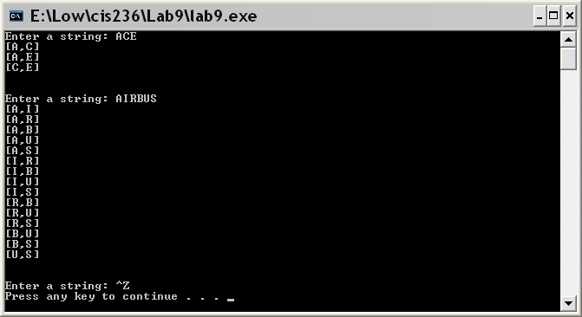

Problem Requirement
a) You must create a file and save it as Program8.c file.
b) The program must have the necessary user-defined recursive function.
c) Your program should run correctly with the same inputs and outputs as given in the sample run.

